**COMP 3410 -**

**Operating Systems (3,1,0)**

**Winter, 2018**

**Lab/assignment 5: Scheduling**

**Individual lab**

**Due: Exam Prep**

1. **Consider the following scenario. The jobs arrived approximately at the same time and the larger number represents the higher priority. Process switching overhead is negligible**

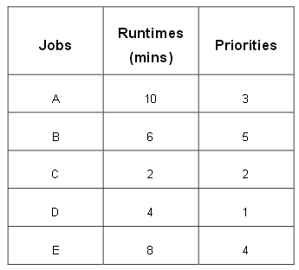

**For each process scheduling algorithm, determine the average turnaround time and the average waiting time. Hint: draw a Gantt chart for the execution:**

1. **First Come First Server (FCFS)**

|  |  |  |  |  |  |  |
| --- | --- | --- | --- | --- | --- | --- |
| **A** | **B** | **C** | **D** | **E** | |  |
| 0 | 10 | 16 | 18 | 22 | 30 | |

1. **Priority Scheduling**

|  |  |  |  |  |
| --- | --- | --- | --- | --- |
| **B** | **E** | **A** | **C** | **D** |
|  |  |  |  |  |

1. **Shortest Job First (SJF)**

|  |  |  |  |  |
| --- | --- | --- | --- | --- |
| **C** | **D** | **B** | **E** | **A** |
|  |  |  |  |  |

1. **Round Robin Scheduling with a quantum length of 2 minutes**

|  |  |  |  |  |  |  |  |  |  |  |  |  |  |  |
| --- | --- | --- | --- | --- | --- | --- | --- | --- | --- | --- | --- | --- | --- | --- |
| **A** | **B** | **C** | **D** | **E** | **A** | **B** | **D** | **E** | **A** | **B** | **E** | **A** | **E** | **A** |
|  |  |  |  |  |  |  |  |  |  |  |  |  |  |  |

1. **Assume you have the following jobs to execute with one processor, with the jobs arriving in the order listed here:**

**i T(pi)**

**0 80**

**1 20**

**2 10**

**3 20**

**4 50**

* 1. **If a system uses FCFS scheduling, create a Gantt chart illustrating the execution of these processes?**
  2. **What is the turnaround time for process p3?**
  3. **What is the average wait time for the processes?**

1. **What scheduling policy will you use for each of the following cases? Explain your reasons for choosing them.** 
   1. **The processes arrive at large time intervals:**
   2. **The system’s efficiency is measured by the percentage of jobs completed.**
   3. **All the processes take almost equal amounts of time to complete.**